**Short study 4**

From: CRUX, a platform for visualising, exploring and analysing cancer genome cohort data, by El-Kamand *et al*.

Please cite the above publication and the authors of any external tools accessed using CRUX.

**Mutation signature analysis of cohort data.**

*Dataset*: We created a new dataset in CRUX by importing published variant calls from a previous study of 30 lung tumours sequenced with deep multi-region whole genome sequencing (WGS), merging this with the associated clinical data. These data are from Leong et al 2019, manuscript reference 24 (PMID: 30348992) and is available from European Nucleotide Archive (https://www.ebi.ac.uk/ena) accession number PRJEB28616. The patients included current, former, and non-smokers, and the tumour biopsies were from paired primary and metastatic tumour biopsies. The data was in VCF file format, which we annotated using a command line vcf2maf tool available at <https://github.com/mskcc/vcf2maf> to create the MAF files employed here. Further clinical annotation used data (CSV filetype) on patient smoking status.

In this study we examine somatic variant signatures in lung cancer data. These signatures are patterns of single nucleotide mutations which can provide mutagenesis mechanisms and other information regarding tumour development; the signatures used are COSMIC V3. Analysis employed two external tools, Mutalisk (http://mutalisk.org/analyze.php) and Signal (<https://www.signaldb.org/>). For this work MAF files are first uploaded, then the additional clinical data (smoking status of participants); these are merged an loaded into CRUX.

From the Import Data selection (under the Data menu on the CRUX sidebar), a panel opens as seen is screenshot 1. After selecting MAF filetyping in Step 1 panel, the relevant MAF file was chosen was located using the Browse button in Step 2 panel then uploaded.

***Screenshot 1***

The additional clinical annotations file was similarly located, selected and uploaded from the STEP 2 panel [screenshot 2].

***Screenshot 2***

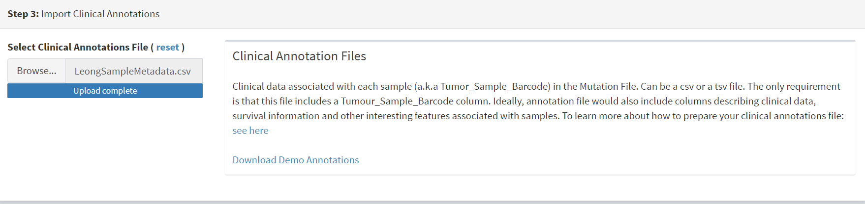

In the Step 4 panel the files were then given the name (‘Lung Cancer’) that they will carry when loaded in CRUX. The Import button (blue) was then pressed [screenshot 3

***Screenshot 3***

Import to CRUX was confirmed after 20 second delay [screenshot 4].

***Screenshot 4***



Selecting the External Tools (CRUX sidebar) opens a page where the dataset is chosen [screenshot 5]. Note that the Dubious Genes filter is not selected as the passenger mutations in these genes are required for the signature analyses.

***Screenshot 5***

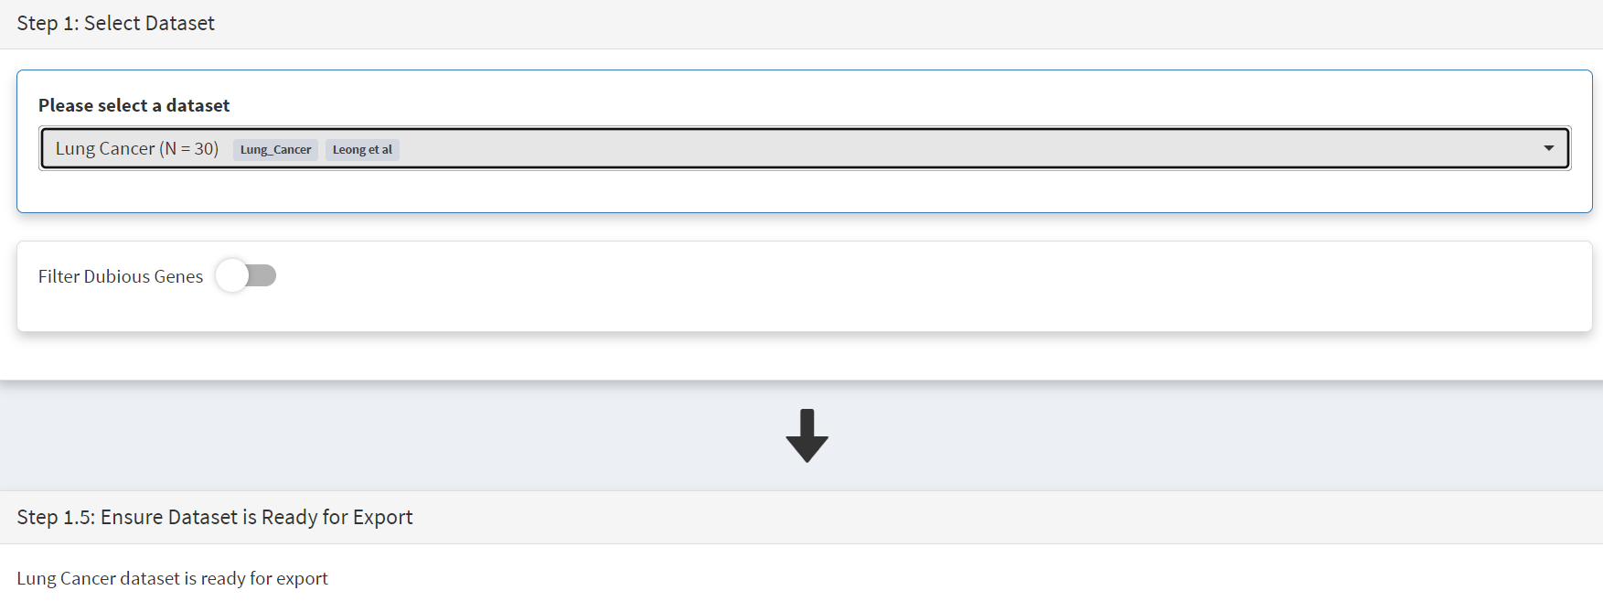

In the External Tools Step 2 panel ‘Mutalisk’ is selected, and the data exported at Step 3; this arrives in the computer download folder as a zipped folder called ‘Lung Cancer_Mutalisk’, the dataset name in CRUX. This contains VCF data files for all the samples, and it is best to open the folder and copy the uncompressed files to a nearby location. These individual files will be uploaded to Mutalisk as described below.

Note that in the Step 5 panel there is information about using Mutalisk:

Instructions

1. Unzip exported file
2. Click 'Upload Files' and select all samples you want to run signature analysis on
3. Select reference build (Human GRCh37 if using pre-packaged TCGA/PCAWG datasets)
4. Select the relevant Disease Type mutalisk will automatically choose relevant signatures to screen in sample. An alternate unbiased approach is to screen against all PCAWG (V3) signatures. To do this expand the PCAWG tab and 'select all' signatures. You do not need to specify a disease.
5. Run analysis

Next press the Go to Mutalisk button selected in Step 4 panel.

***Screenshot 6***

CRUX then opens a browser window running Mutalisk [screenshot 7].

***Screenshot 7***

However, the ‘COSMIC’ signatures are not the most up to date. To select the correct type of COSMIC V3 signatures it is necessary to select the PCAWG – Sig profiler option below it. Then the signature types to be examined are designated using the Select all button [screenshot 8].

***Screenshot 8***

Then the +Add Files option is pressed, the files exported from CRUX are chosen (unzipped) and the files are processed [screenshot 9]. The RUN button is then pressed and the analysis proceeds as indicated. Note that this processing is slow and can take several hours for 30 samples. The initial stage of processing is shown in screenshot 9. Mutalisk gives a process number so the user can exit and return to see progress later.

***Screenshot 9***

Mutalisk then outputs a number of analyses for each dataset input. Some of these are in downloaded PDF files; examples for LUAD1 are shown in screenshots 10 to 13. For example, screenshots 10 and 11 show kataegis analysis output for LUAD1 and LUAD7, respectively, showing a predominance of C>A mutations in the latter but not the former.

***Screenshot 10***

***Screenshot 11***

Screenshot 12 shows the Mutalisk signature output from sample LUAD7_primary1, a primary lung tumour showing a typical smokers profile with high SBS4. Highlighted (blue line) is the signature plot presented in El-Kamand et al Figure 5C (recoloured for clarity). The signature proportion varies slightly over time as the signature data is updated in the Mutalisk portal.

***Screenshot 12***

Screenshot 13 shows the Mutalisk signature output from sample LUAD1_metA, a lung tumour metastasis showing a non-typical smokers profile no detectable SBS4. Signature plot is highlighted (blue line) in El-Kamand et al Figure 5C (recoloured for clarity).

***Screenshot 13***

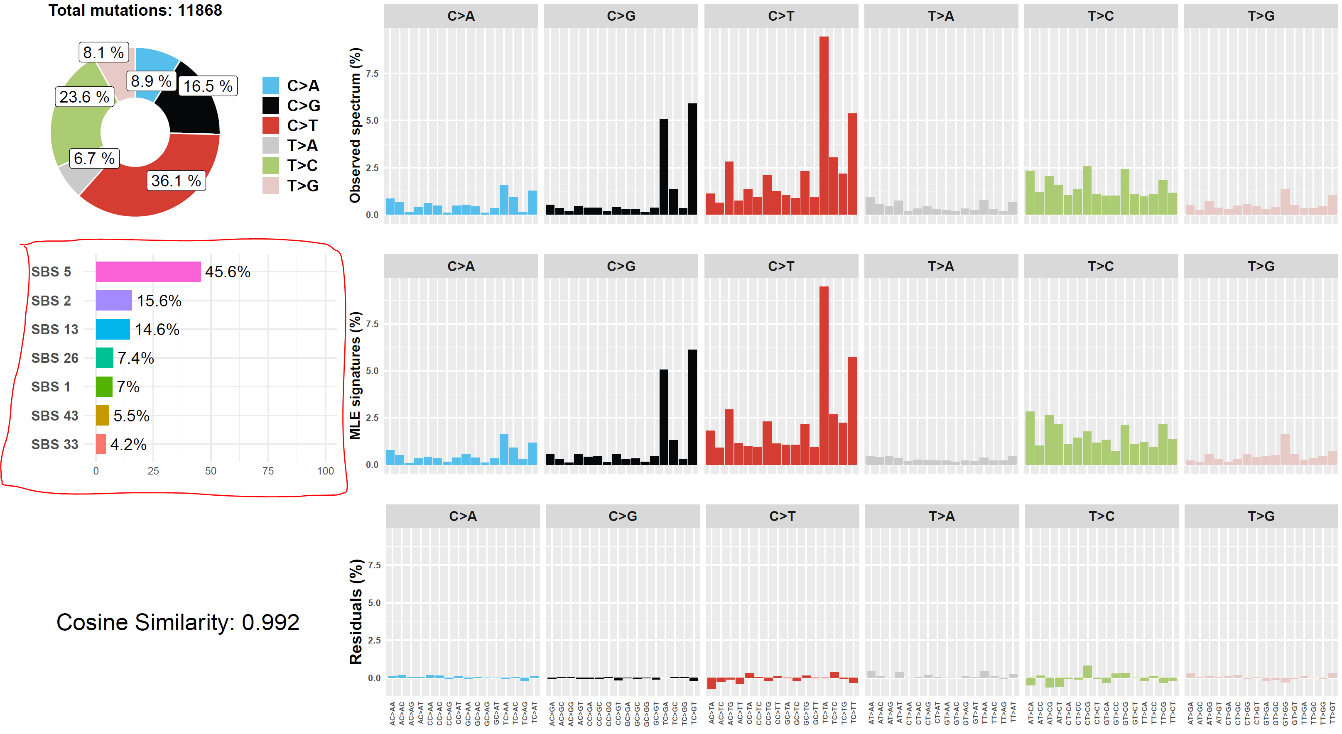

However, for cohort wide analysis we need to load the Mutalisk data into CRUX. At the top of the Mutalisk page the ‘Get the selected result for all samples a once’ button is pressed [screenshot 14, red line highlight].

***Screenshot 14***

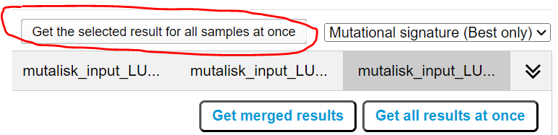

This downloads a zip file with a filename ending in ‘.all.samples.zip’. The next step uses these files downloaded from Mutalisk, which are first unzipped files and placed in an accessible folder for CRUX to navidgate to; example files from a containing folder shown in screenshot 15. CRUX will ignore the PDF files.

***Screenshot 15***

When the Mutalisk files are ready, the Mutational Signatures tab (under the Single Cohort Genomics menu located on the CRUX sidebar) is then selected to open a new page of panels [screenshot 16]. On the first (Step 1) panel the Lung Cancer data is selected using the ‘Please select a dataset’ field. Then on the Step 2 panel the instructions given in the panel have already been followed by this point, so the the next action is to press the Browse button, and navigate to where the unipped Mutalisk files are located. Those files are selected and opened by CRUX, which may take a minute. When finished the blue ‘Upload Complete’ bar should appear below.

***Screenshot 16***

The next panels should then be visible. Step 3 panel shows a Venn diagram indicating that the MAF and Mutalisk data match up [screenshot 17]. Note that the Filter Dubious Genes option is off.

***Screenshot 17***

The Step 4 panel (Review Tabular Data) contains the data table, including the signature variants and their contributions for each sample; part of the table is shown on screenshot 18 with some details blanked. This data can be subsetted and searched but is more easily comprehended in the next Step.

***Screenshot 18***

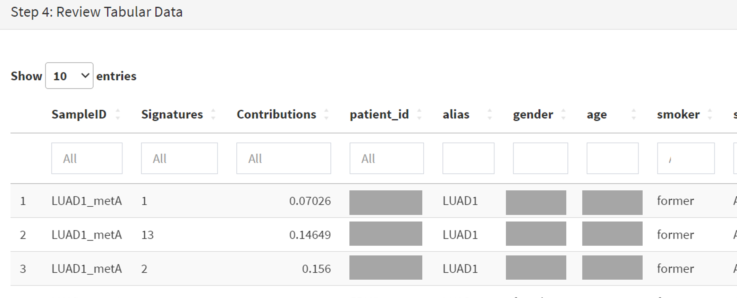

The Step 5 panel [screenshot 19] shows the visualisation of the signature contributions (X-axis) for each tissue sample. There are multiple tissue samples (tumour primary samples and metastasis samples) for comparison. Note that colours are set by Mutalisk, so in the El-Kamand et al manuscript the chart colours have been adjusted for clarity.

***Screenshot 19***

Pressing the Download button at the bottom brings up the download options shown in screenshot 20.

***Screenshot 20***

Next further signature analysis can be performed using the external Signal tool with the Lung cancer data loaded into CRUX as above.

As for Mutalisk above, we first navigate to the External tool tab on the sidebar and open that page. In the Step 1 panel the Lung Cancer dataset is selected [screenshot 21]

***Screenshot 21***

On the Step 2 panel the Signal tool is selected [screenshot 22] and the data for export is downloaded using the Export Data button. Note again that the Filter Dubious genes is off, since for signature analysis we are not concerned with gene drivers but the general pattern of mutations present compared to those seen in other cancers.

***Screenshot 22***

The filename zipped file provided is ‘Lung cancer_Signal.zip’. As described in the Step 5 panel, unzip the file (‘signal_input1.txt’) and navigate to the Signals portal (<https://signal.mutationalsignatures.com/analyse2>).

The blue Go to Signal button is press and Signal website opens in a new browser screen, as shown in screenshot 23.

***Screenshot 23***

The upload data button is then pressed, which opens the upload file page [screenshot 24]. Here, the signal_input1.txt file from CRUX is uploaded according to instructions.

***Screenshot 24***

When the file finishes upload the file format must be selected as ‘[Variants]/TSV/TXT’ as seen in the screenshot 25. The reference genome build selected (here GRCh37) and the organ chosen, here LUNG.

***Screenshot 25***

When the analysis is done there are a number of panels that are used to access the analysis of individual lung cancer datasets; the first six shown in screenshot 26.

***Screenshot 26***

Here we are interested in tumours LUAD1_metA and LUAD7 primary1 used in the El-Kamand et al manuscript. Clicking on the LUAD1_metA panel brings a number of plots describing single nucleotide variants (SNV) types and frequencies, and the proportion of COSMIC V23 signal seen in the variant complement of this tumour. The first data shown is the Substitution catalogue, the pattern of nucleotide substitutions in this tumour; this is shown in screenshot 27.

***Screenshot 27***

There are a number of analyses we can perform from this page, listed at the bottom, including strand bias, mutation density, replication timing and similar samples. For each there is a text hyperlink at the bottom of the page leading to the relevant page.

The Signatures analysis shows the relative preponderance of defined COSMIC V3 signatures detected in the sample mutations [screenshot 28]; note that there are a range of other related visualisation provided on this page.

***Screenshot 28***

The Similar Samples analysis is of particular interest as it can indicate which type of tumours (available to this database) most resemble the mutation patterns seen in this LUAD1 tumour. Screenshot 29 shows the Similar Samples data page.

***Screenshot 29***

Screenshot 30 shows the output when the analysis is run. The analysis is run with a cosine threshold of 0.96 – the pie chart is similar to that used in the El-Kamand manuscript figure 5D

***Screenshot 30***

This signature data suggests that the cancer LUAD1 has a pattern of variant that most closely resembles that of Breast Cancer, and only poorly matches Lung cancers.

Next is the analysis of the LUAD7_primary1 tumour, first showing the substitution catalogue which can be seen to be very different to the LUAD7 tumour [screenshot 31].

***Screenshot 31***

LUAD7 sample Signatures analysis (COSMIC V3 signatures) in this sample is shown in screenshot 32. Note the prominent SBS4 smoking associated signature, absent in LUAD1.

***Screenshot 32***

The Similar Sample analysis of LUAD7 sample greatly resembles Lung cancers, unlike (again) LUAD1 [screenshot 33]. This may reflect a preponderance of lung cancers in the Signal database that are caused by smoking.

***Screenshot 33***

